ICEngineSoft Test Report

Report Date : Wed, Dec 14, 2022 , Time : 12:57:56 AM
Organization : Organisation, Operator : Operator
Data File : 13-12 WCO-LDPE B10.xlsx, Last Modified Date: Tue, Dec 13, 2022,
Config. File : Kirloskar TV1 Engine.xls

Engine Details :

ICEngine set up under test is Kirloskar TV1 having power 5.20 kW @ 1500 rpm which is 1 Cylinder, Four stroke , Constant Speed, Water Cooled, Diesel Engine, with Cylinder Bore 87.50(mm), Stroke Length 110.00(mm), Connecting Rod length 234.00(mm), Compression Ratio 17.50, Swept volume 661.45 (cc)

Combustion Parameters :

Specific Gas Const (kJ/kgK) : 1.00, Air Density (kg/m^3) : 1.17, Adiabatic Index : 1.41, Polytrophic Index : 1.10, Number Of Cycles : 10, Cylinder Pressure Referance : 6, Smoothing 2, TDC Reference :-1

Performance Parameters :

Orifice Diameter (mm) : 20.00, Orifice Coeff. Of Discharge : 0.60, Dynamometer Arm Legnth (mm) : 185, Fuel Pipe dia (mm) : 12.40, Ambient Temp. (Deg C) : 27, Pulses Per revolution : 360, Fuel Type : Diesel, Fuel Density (Kg/m^3) : 833, Calorific Value Of Fuel (kj/kg) : 42050

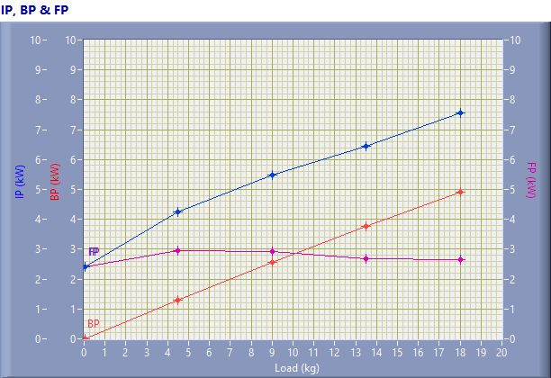

IP, BP & FP

Speed (rpm) | Load (kg) | IP (kW) | BP (kW) | FP (kW)
1592.00 | 0.03 | 2.42 | 0.01 | 2.41
1506.00 | 4.50 | 4.24 | 1.29 | 2.95
1499.00 | 9.01 | 5.48 | 2.57 | 2.91
1464.00 | 13.50 | 6.43 | 3.76 | 2.68
1433.00 | 18.02 | 7.56 | 4.91 | 2.65

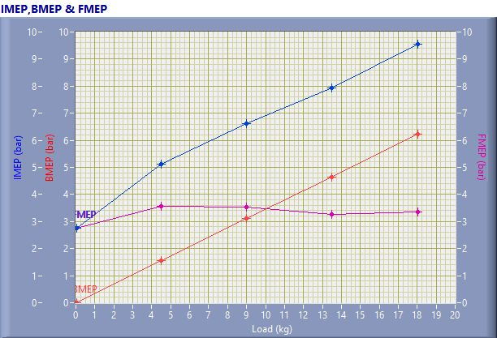

IMEP,BMEP & FMEP

Speed (rpm) | Load (kg) | IMEP (bar) | BMEP (bar) | FMEP (bar)
1592.00 | 0.03 | 2.76 | 0.01 | 2.75
1506.00 | 4.50 | 5.11 | 1.55 | 3.56
1499.00 | 9.01 | 6.63 | 3.11 | 3.52
1464.00 | 13.50 | 7.92 | 4.66 | 3.26
1433.00 | 18.02 | 9.57 | 6.21 | 3.35

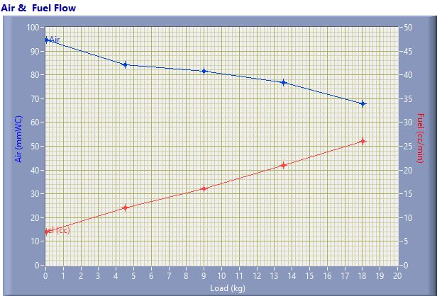

Air & Fuel Flow

Speed (rpm) | Load (kg) | Air (mmWC) | Fuel (cc/min)
1592.00 | 0.03 | 94.53 | 7.00
1506.00 | 4.50 | 84.08 | 12.00
1499.00 | 9.01 | 81.52 | 16.00
1464.00 | 13.50 | 76.73 | 21.00
1433.00 | 18.02 | 68.00 | 26.00

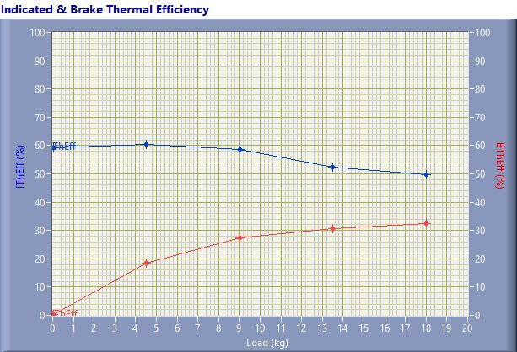

Indicated & Brake Thermal Efficiency

Speed (rpm) | Load (kg) | IThEff (%) | BThEff (%)
1592.00 | 0.03 | 59.29 | 0.24
1506.00 | 4.50 | 60.54 | 18.40
1499.00 | 9.01 | 58.64 | 27.48
1464.00 | 13.50 | 52.49 | 30.64
1433.00 | 18.02 | 49.78 | 32.34

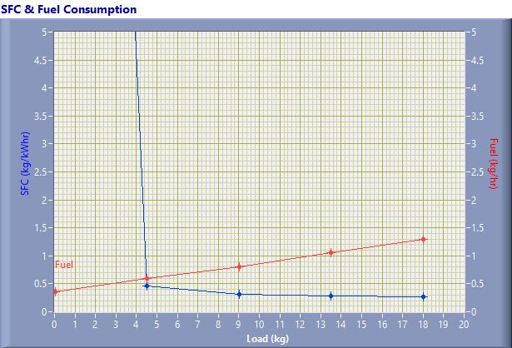

SFC & Fuel Consumption

Speed (rpm) | Load (kg) | SFC (kg/kWh) | Fuel (kg/h)
1592.00 | 0.03 | 36.14 | 0.35
1506.00 | 4.50 | 0.47 | 0.60
1499.00 | 9.01 | 0.31 | 0.80
1464.00 | 13.50 | 0.28 | 1.05
1433.00 | 18.02 | 0.26 | 1.30

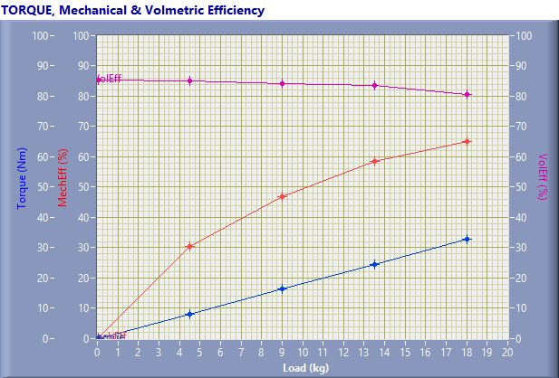

TORQUE, Mechanical & Volmertic Efficiency

Speed (rpm) | Load (Kg) | Torque (Nm) | Mech Eff. (%) | Vol Eff. (%)
1592.00 | 0.03 | 0.06 | 0.40 | 85.38
1506.00 | 4.50 | 8.17 | 30.39 | 85.12
1499.00 | 9.01 | 16.35 | 46.87 | 84.21
1464.00 | 13.50 | 24.50 | 58.38 | 83.65
1433.00 | 18.02 | 32.71 | 64.96 | 80.45

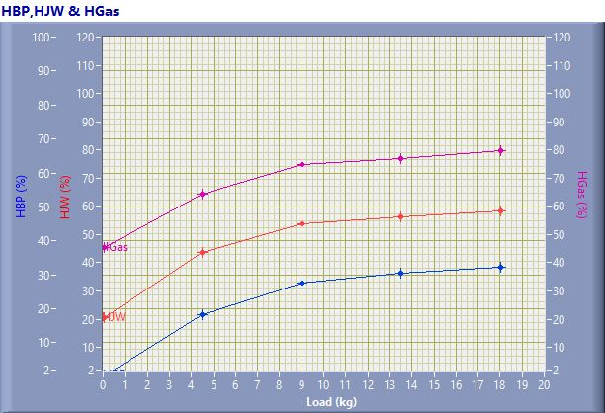

HBP,HJW & HGas

Speed (rpm) | Load (kg) | HBP (%) | HJW (%) | HGas (%) | HRad (%)
1592.00 | 0.03 | 0.24 | 20.27 | 24.79 | 54.70
1506.00 | 4.50 | 18.40 | 25.12 | 20.94 | 35.54
1499.00 | 9.01 | 27.48 | 26.37 | 21.10 | 25.05
1464.00 | 13.50 | 30.64 | 25.64 | 20.61 | 23.11
1433.00 | 18.02 | 32.34 | 26.07 | 21.40 | 20.20

Observation Data

Speed (rpm) | Load (kg) | Comp Ratio | T1 (deg C) | T2 (deg C) | T3 (deg C) | T4 (deg C) | T5 (deg C) | T6 (deg C)
1592 | 0.03 | 17.50 | 38.47 | 43.20 | 38.47 | 37.69 | 130.55 | 104.84
1506 | 4.50 | 17.50 | 38.55 | 48.61 | 38.57 | 39.91 | 184.61 | 140.41
1499 | 9.01 | 17.50 | 38.63 | 52.70 | 38.63 | 42.35 | 240.54 | 178.54
1464 | 13.50 | 17.50 | 38.69 | 56.65 | 38.69 | 45.45 | 306.53 | 224.10
1433 | 18.02 | 17.50 | 38.77 | 61.39 | 38.77 | 49.86 | 397.16 | 281.30

Observation Data

Air (mmWC) | Fuel (cc/min) | WaterFlow Engine (lph) | WaterFlow Cal (lph)
94.53 | 7.00 | 150 | 75
84.08 | 12.00 | 150 | 75
81.52 | 16.00 | 150 | 75
76.73 | 21.00 | 150 | 75
68.00 | 26.00 | 150 | 75

Result Data

Torque (Nm) | BP (kW) | FP (kW) | IP (kW) | BMEP (bar) | IMEP (bar) | BTHE (%) | ITHE (%) | Mech Eff. (%)
0.06 | 0.01 | 2.41 | 2.42 | 0.01 | 2.76 | 0.24 | 59.29 | 0.40
8.17 | 1.29 | 2.95 | 4.24 | 1.55 | 5.11 | 18.40 | 60.54 | 30.39
16.35 | 2.57 | 2.91 | 5.48 | 3.11 | 6.63 | 27.48 | 58.64 | 46.87
24.50 | 3.76 | 2.68 | 6.43 | 4.66 | 7.92 | 30.64 | 52.49 | 58.38
32.71 | 4.91 | 2.65 | 7.56 | 6.21 | 9.57 | 32.34 | 49.78 | 64.96

Result Data

Air Flow (kg/h) | Fuel Flow (kg/h) | SFC (kg/kWh) | Vol Eff. (%) | A/F Ratio | HBP (%) | HJW (%) | HGas (%) | HRad (%)
31.66 | 0.35 | 36.14 | 85.38 | 90.50 | 0.24 | 20.27 | 24.79 | 54.70
29.86 | 0.60 | 0.47 | 85.12 | 49.79 | 18.40 | 25.12 | 20.94 | 35.54
29.40 | 0.80 | 0.31 | 84.21 | 36.77 | 27.48 | 26.37 | 21.10 | 25.05
28.53 | 1.05 | 0.28 | 83.65 | 27.18 | 30.64 | 25.64 | 20.61 | 23.11
26.86 | 1.30 | 0.26 | 80.45 | 20.67 | 32.34 | 26.07 | 21.40 | 20.20

